**EXPERIMENT7**

**Student Name:** Saksham Kumar **UID:**22BET10333

**Branch:** BE -IT **Section/Group:**22BET_IOT-703(B)

**Semester:** 6th **Subject Code:** 22ITP-351

**PROBLEM-1**

**AIM:-**

[Climbing Stairs](https://leetcode.com/problems/longest-nice-substring/)

**CODE:-**

class Solution {

    public int climbStairs(int n) {

        if (n == 0 || n == 1) {

            return 1;

        }

        int[] dp = new int[n+1];

        dp[0] = dp[1] = 1;

        for (int i = 2; i <= n; i++) {

            dp[i] = dp[i-1] + dp[i-2];

        }

        return dp[n];

    }

}

**OUTPUT:-**

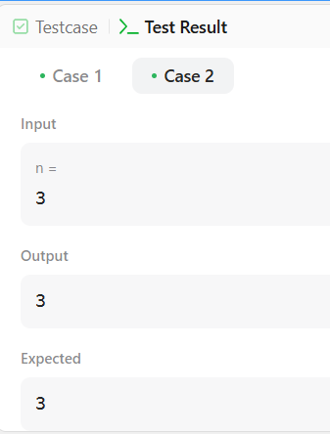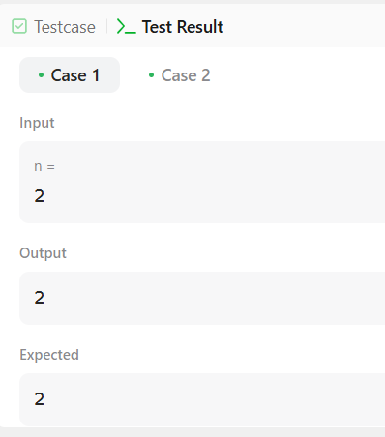

**PROBLEM-2**

**AIM:-**

Best Time to Buy and Sell a Stock

**CODE:**-

class Solution {

public int maxProfit(int[] prices) {

int buy = prices[0];

int profit = 0;

for (int i = 1; i < prices.length; i++) {

if (prices[i] < buy) {

buy = prices[i];

} else if (prices[i] - buy > profit) {

profit = prices[i] - buy;

}

}

return profit;

}

}

}**OUTPUT:-**

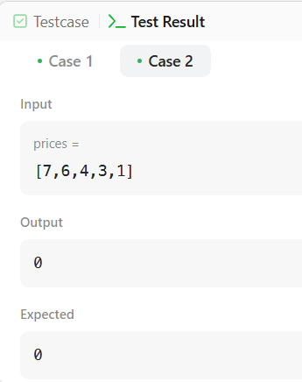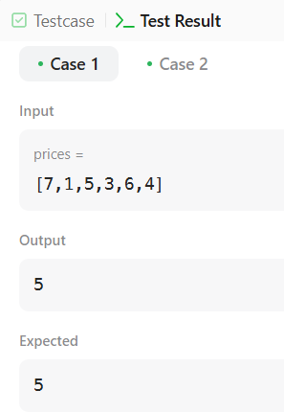

**PROBLEM-3**

**AIM:-**

Maximum Subarray

**CODE:-**

class Solution {

public int maxSubArray(int[] nums) {

int res = nums[0];

int total = 0;

for (int n : nums) {

if (total < 0) {

total = 0;

}

total += n;

res = Math.max(res, total);

}

return res;

}

}

}

**OUTPUT:**

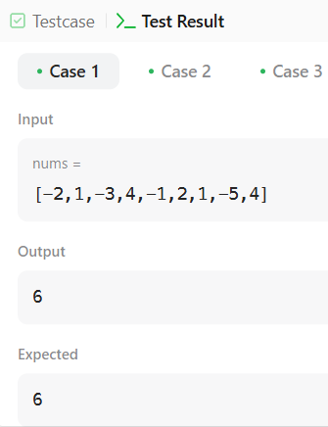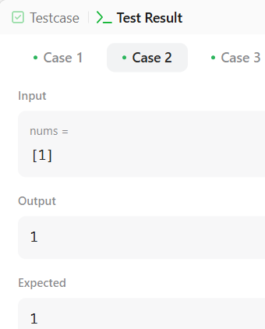

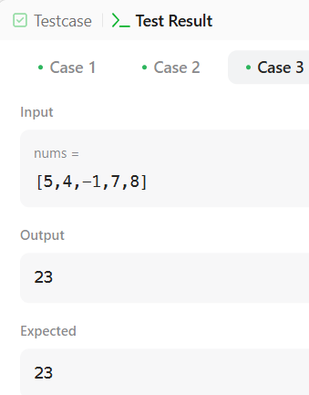

**PROBLEM-4**

**AIM:-**

House Robber

**CODE:-**

class Solution {

public int rob(int[] nums) {

int n = nums.length;

if (n == 1) {

return nums[0];

}

int[] dp = new int[n];

dp[0] = nums[0];

dp[1] = Math.max(nums[0], nums[1]);

for (int i = 2; i < n; i++) {

dp[i] = Math.max(dp[i - 1], nums[i] + dp[i - 2]);

}

return dp[n - 1];

}

}

**OUTPUT:-**

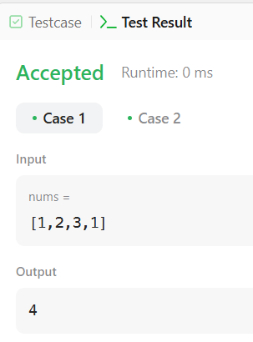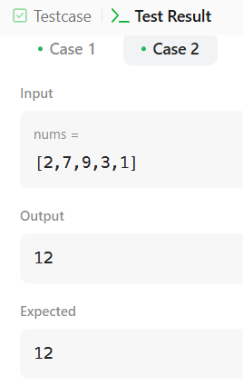

**PROBLEM-5**

**AIM:-**

Jump Game

**CODE:-**

class Solution {

public boolean canJump(int[] nums) {

int goal = nums.length - 1;

for (int i = nums.length - 2; i >= 0; i--) {

if (i + nums[i] >= goal) {

goal = i;

}

}

return goal == 0;

}

}

**OUTPUT:-**

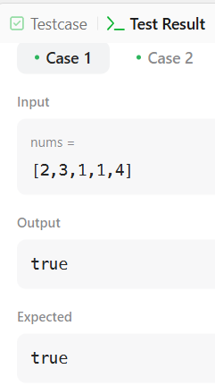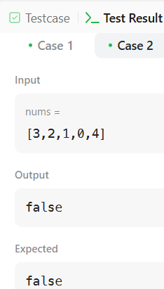

**PROBLEM-6**

**AIM:-**

Unique Paths

**CODE:-**

class Solution {

public int uniquePaths(int m, int n) {

int[] aboveRow = new int[n];

Arrays.fill(aboveRow, 1);

for (int row = 1; row < m; row++) {

int[] currentRow = new int[n];

Arrays.fill(currentRow, 1);

for (int col = 1; col < n; col++) {

currentRow[col] = currentRow[col - 1] + aboveRow[col];

}

aboveRow = currentRow;

}

return aboveRow[n - 1];

}

}**OUTPUT:-**

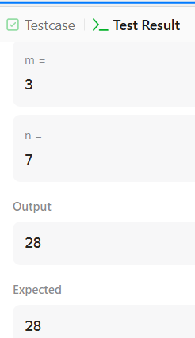

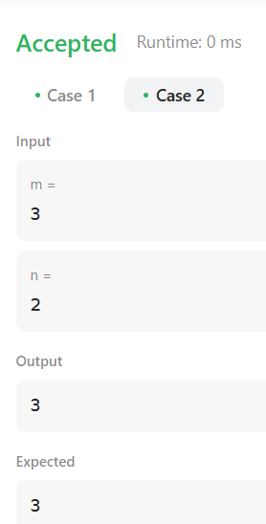

**PROBLEM-7**

**AIM:-**

Coin Change

**CODE:-**

import java.util.*;

public class Solution {

public static int coinChange(int[] coins, int target) {

if (target == 0)

return 0;

int n = coins.length;

if (n == 1)

return target % coins[0] == 0 ? target / coins[0] : -1;

Arrays.sort(coins);

int minCoin = coins[0];

if (target == minCoin)

return 1;

int idx = 1, gcdVal = minCoin;

while (idx < n && target >= coins[idx]) {

if (target == coins[idx])

return 1;

gcdVal = gcd(coins[idx], gcdVal);

coins[idx] -= minCoin;

idx++;

}

if (target % gcdVal != 0)

return -1;

int minVal = (target - 1) / (coins[idx - 1] + minCoin) + 1;

int maxVal = target / minCoin;

for (int i = minVal; i <= maxVal; i++) {

if (findCombination(coins, 1, idx - 1, target - i * minCoin, i))

return i;

}

return -1;

}

private static boolean findCombination(int[] coins, int left, int right, int target, int maxCoins) {

if (target == 0)

return true;

if (target < coins[left] || target / coins[right] > maxCoins)

return false;

if (target % coins[right] == 0)

return true;

if (left == right)

return false;

for (int k = target / coins[right] + 1; k-- > 0; ) {

if (findCombination(coins, left, right - 1, target - k * coins[right], maxCoins - k))

return true;

}

return false;

}

private static int gcd(int a, int b) {

while (b != 0) {

int temp = b;

b = a % b;

a = temp;

}

return a;

}

}

